UNIT 7 – SCHOOL IS OVER – Speak English and Have Fun (3 sata)
Učenik će :
- čitati tekst s razumijevanjem
- govoriti o Australiji, Kanadi i Novom Zelandu
prevoditi i objašnjavati izraze sinonimima i parafrazama
udžbenik, str. 124., 125., 126.,127., radna bilježnica, str. 118., 119., 121
Dragi učenici,
Ova se lekcija radi 3 nastavna sata. Kako biste mogli pravilno riješiti zadatke, potrebno je ispisati nepoznate riječi u bilježnicu, ponavljati i, čitati tekstove u udžbeniku, a na kraju provježbati gradivo zadacima u radnoj bilježnici.
STEP 1
Učenici promotre fotografije u zadatku A, udž., str. 124., navode odredišta za odmor i govore što im je zajedničko (1. New Zealand 2. Toronto 3. kangaroos (Australia) 4. Iceberg Alley (Canada) 5. Rotorua, New Zealand 6. Sydney Opera House. They are all situated in English-speaking countries.).
Učenici razvrstavaju riječi iz zadatka B, udž., str. 124.
Učenik čita tekst (udž., str.125.) o zemlji provjeravajući prijašnja predviđanja i podcrtavajući izraze u zadatku B, zatim rješava zadatak D, udž., str., 124. Učenici povezuju rečenice u zadatku E, udž., str. 126.

STEP 2
Učenici zatim rješavaju zadatak Fi G, udž., str. 126.

Plan ploče Schoolwork Date

1st conditional If + present simple, will + infinitive

1Ice hockey. 2. Near Melbourne. 3. The Lord of the Rings.
Australia, Canada, Toronto, Niagara Falls, Bondi Beach, Northern Territory, Kangaroo Island, Great Barrier Reef, St Lawrence River, Atlantic Ocean, north, south, Titanic, Phillip Island Nature Park

peninsula
vineyard
rural estates
medieval
amphitheatre

STEP 3
Podsjetimo ih na pravila izgovora određenog člana the.
Učenici rješavaju REMEMBER!, udž., str. 127.
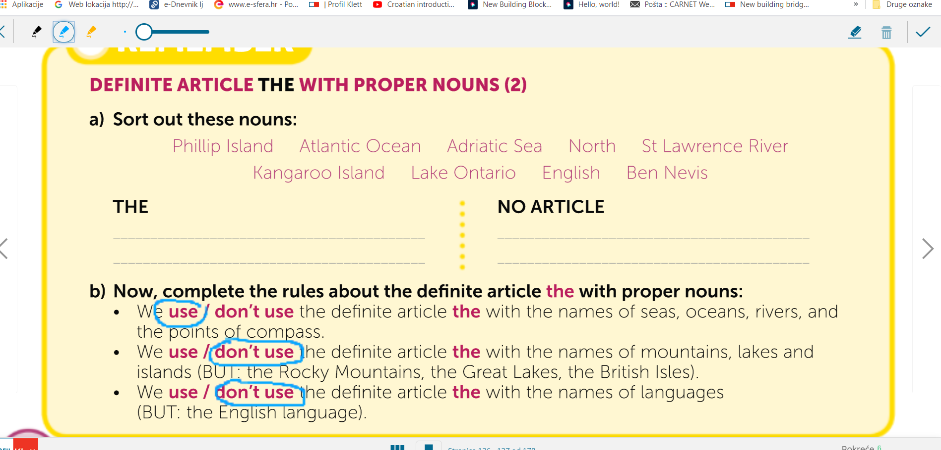
(Answer key: a) THE – Atlantic Ocean, Adriatic Sea, North, St Lawrence River; NO ARTICLE – Kangaroo Island, Lake Ontario, English, Ben Nevis b) use, don’t use, don’t use)
Učenici rješavaju zadatak H i I, udž., str. 127.

(Answer key: 1 The 2 the 3 – 4 – 5 – 6 the 7 the 8 – 9 the 10 – 11 the 12 – 13 – 14 – 15 the 16 the 17 – 18 – 19 – 20 the 21 – )

STEP 4
the quiz- Odgovore prvo napišite u bilježnice.
HOW MUCH DO YOU KNOW ABOUT THE ENGLISH SPEAKING COUNTRIES?
QUIZ
1 Name two extreme sports which originated in New Zealand.
2 What is the name of the longest coral reef in the world?
3 What is the name of the world’s largest monolith, one of Australia’s greatest attractions?
4 Where is Rotorua and what is special about it?
5 Name two animals you can see at Phillip Island Nature Park near Melbourne.
6 What is the national sport of Canada?
7 What’s the name of the most famous beach in the suburbs of Sydney?
8 Where in Australia is the Balloon Fiesta held?
9 Which Canadian tourist attraction belongs to the Seven Wonders of the World?
10 What is special about Christmas in Australia?
11 What are keas and where can you see them?
12 What do New Zealanders call themselves?

Odgovore na ovih 12 pitanja vrednujem pa mi ih pošaljite na uvid pretipkane u privatnoj poruci.

STEP 5
Radna bilježnica

Good luck!

