1B THE WAY WE ARE

12

Look at the words and pictures. Copy the words in English on the empty lines.
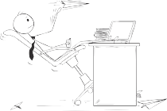
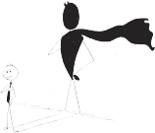
Pogledaj riječi i slike. Prepiši engleske riječi na prazne crte.

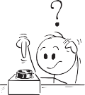
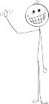
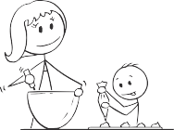
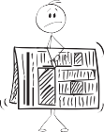
HA-HA

1 lazy |  | lijen
2 brave |  | hrabar
3 clever |  | pametan
4 curious |  | znatiželjan
5 friendly |  | prijateljski raspoložen
6 funny |  | smiješan
7 hardworking |  | marljiv
8 helpful |  | spreman pomoći
9 shy |  | sramežljiv
10 strict |  | strog

c) Translate the words into Croatian.
Prevedi riječi na hrvatski jezik.

- lazy 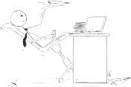
- curious 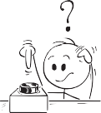
- strict
- shy 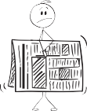
- clever
- brave 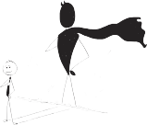
- helpful 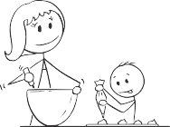
- hardworking
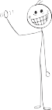
- friendly
HA-HA

- funny

GRAMMAR!
My...

VERB TO BE – how do we ask questions?
GLAGOL BITI – kako postavljamo pitanja?

Look at the sentences.
Pogledaj rečenice.

I am funny.  Am I funny? | George is from the UK. Is George from the UK?
Ja sam smiješan / smiješna. Jesam li ja smiješan / smiješna? | George je iz Velike Britanije. Je li George iz Velike Britanije?

LOOK AND READ! |  | POGLEDAJ I PROČITAJ!
+ | ? | + | ?
I am brave. | Am I brave? | Ja sam hrabar / hrabra. | Jesam li ja hrabar  / hrabra?
You are brave. | Are you brave? | Ti si hrabar  / hrabra. | Jesi li ti hrabar  / hrabra?
He is brave. She is brave.  It is brave. | Is he brave?  Is she brave?  Is it brave? | On je hrabar. Ona je hrabra.  Ono je hrabro. | Je li on hrabar? Je li ona hrabra?  Je li ono hrabro?
We are brave.  You are brave. They are brave. | Are we brave?  Are you brave?  Are they brave? | Mi smo hrabri. Vi ste hrabri.  Oni su hrabri. | Jesmo li mi hrabri? Jeste li vi hrabri?  Jesu li oni hrabri?

42

Make questions.
Postavi pitanja.
1 I am curious.

Am I curious?

- We are friendly.
- You are a dreamer.
- She is hardworking.

- George is nine. 6 George’s dad is clever. 7 Sam and Emma are George’s friends. 8 Hermes is funny.

GRAMMAR!
My...

VERB TO BE – questions and short answers
GLAGOL BITI – pitanja i kratki odgovori

LOOK AND READ! |  | POGLEDAJ I PROČITAJ!
Am I shy? | Yes, I am. /  No, I’m not. | Jesam li ja sramežljiv  / sramežljiva? | Da, jesam. /  Ne, nisam.
Are you shy? | Yes, you are. /  No, you aren’t. | Jesi li ti sramežljiv  / sramežljiva? | Da, jesi. /  Ne, nisi.
Is he shy? | Yes, he is. /  No, he isn’t. | Je li on sramežljiv? | Da, jest. /  Ne, nije.
Is she shy? | Yes, she is. /  No, she isn’t. | Je li ona sramežljiva? | Da, jest. /  Ne, nije.
Is it shy? | Yes, it is. /  No, it isn’t. | Je li ono sramežljivo? | Da, jest. /  Ne, nije.
Are we shy? | Yes, we are. /  No, we aren’t. | Jesmo li mi sramežljivi? | Da, jesmo. /  Ne, nismo.
Are you shy? | Yes, you are. /  No, you aren’t. | Jeste li vi sramežljivi? | Da, jeste. /  Ne, niste.
Are they shy? | Yes, they are. /  No, they aren’t. | Jesu li oni sramežljivi? | Da, jesu. /  Ne, nisu.

52
Read the questions and circle the answer that is true for you.
Sjećaš li se Georgea i njegove obitelji? Pročitaj pitanja i zaokruži odgovor
koji je točan za tebe.

- Is my mum friendly? Yes, she is. No, she isn’t.
- Are my friends curious? Yes, they are. No, they aren’t. 3 Am I brave? Yes, I am. No, I’m not.
4 Is my dad funny? Yes, he is. No, he isn’t. 5 Is my neighbour hardworking? Yes, he is. No, he isn’t.

- Is my pet lazy? Yes, it is. No, it isn’t.
- Are my friends helpful? Yes, they are. No, they aren’t. Are my teachers strict? Yes, they are. No, they aren’t. Is my grandma clever? Yes, she is. No, she isn’t.
10 Is my grandpa shy? Yes, he is. No, he isn’t.

62

Answer the questions about yourself. Write: Yes, I am. or No, I’m not.
Odgovori na pitanja o sebi. Napiši: Yes, I am. ili No, I’m not.

- Are you shy? _____________________________________________
Jesi li sramežljiv / sramežljiva?
- Are you friendly? __________________________________________
Jesi li prijateljski raspoložen / raspoložena?
- Are you hardworking at school? ______________________________
Jesi li marljiv / marljiva u školi?

- Are you curious? __________________________________________
Jesi li znatiželjan / znatiželjna?
- Are you lazy? _____________________________________________
Jesi li lijen / lijena?
- Are you a dreamer? ____________________________________________
Jesi li sanjar?

